William Carey Bible Institute
Cover Page

Student name
Diploma name
Course name
Assignment
Date of submission
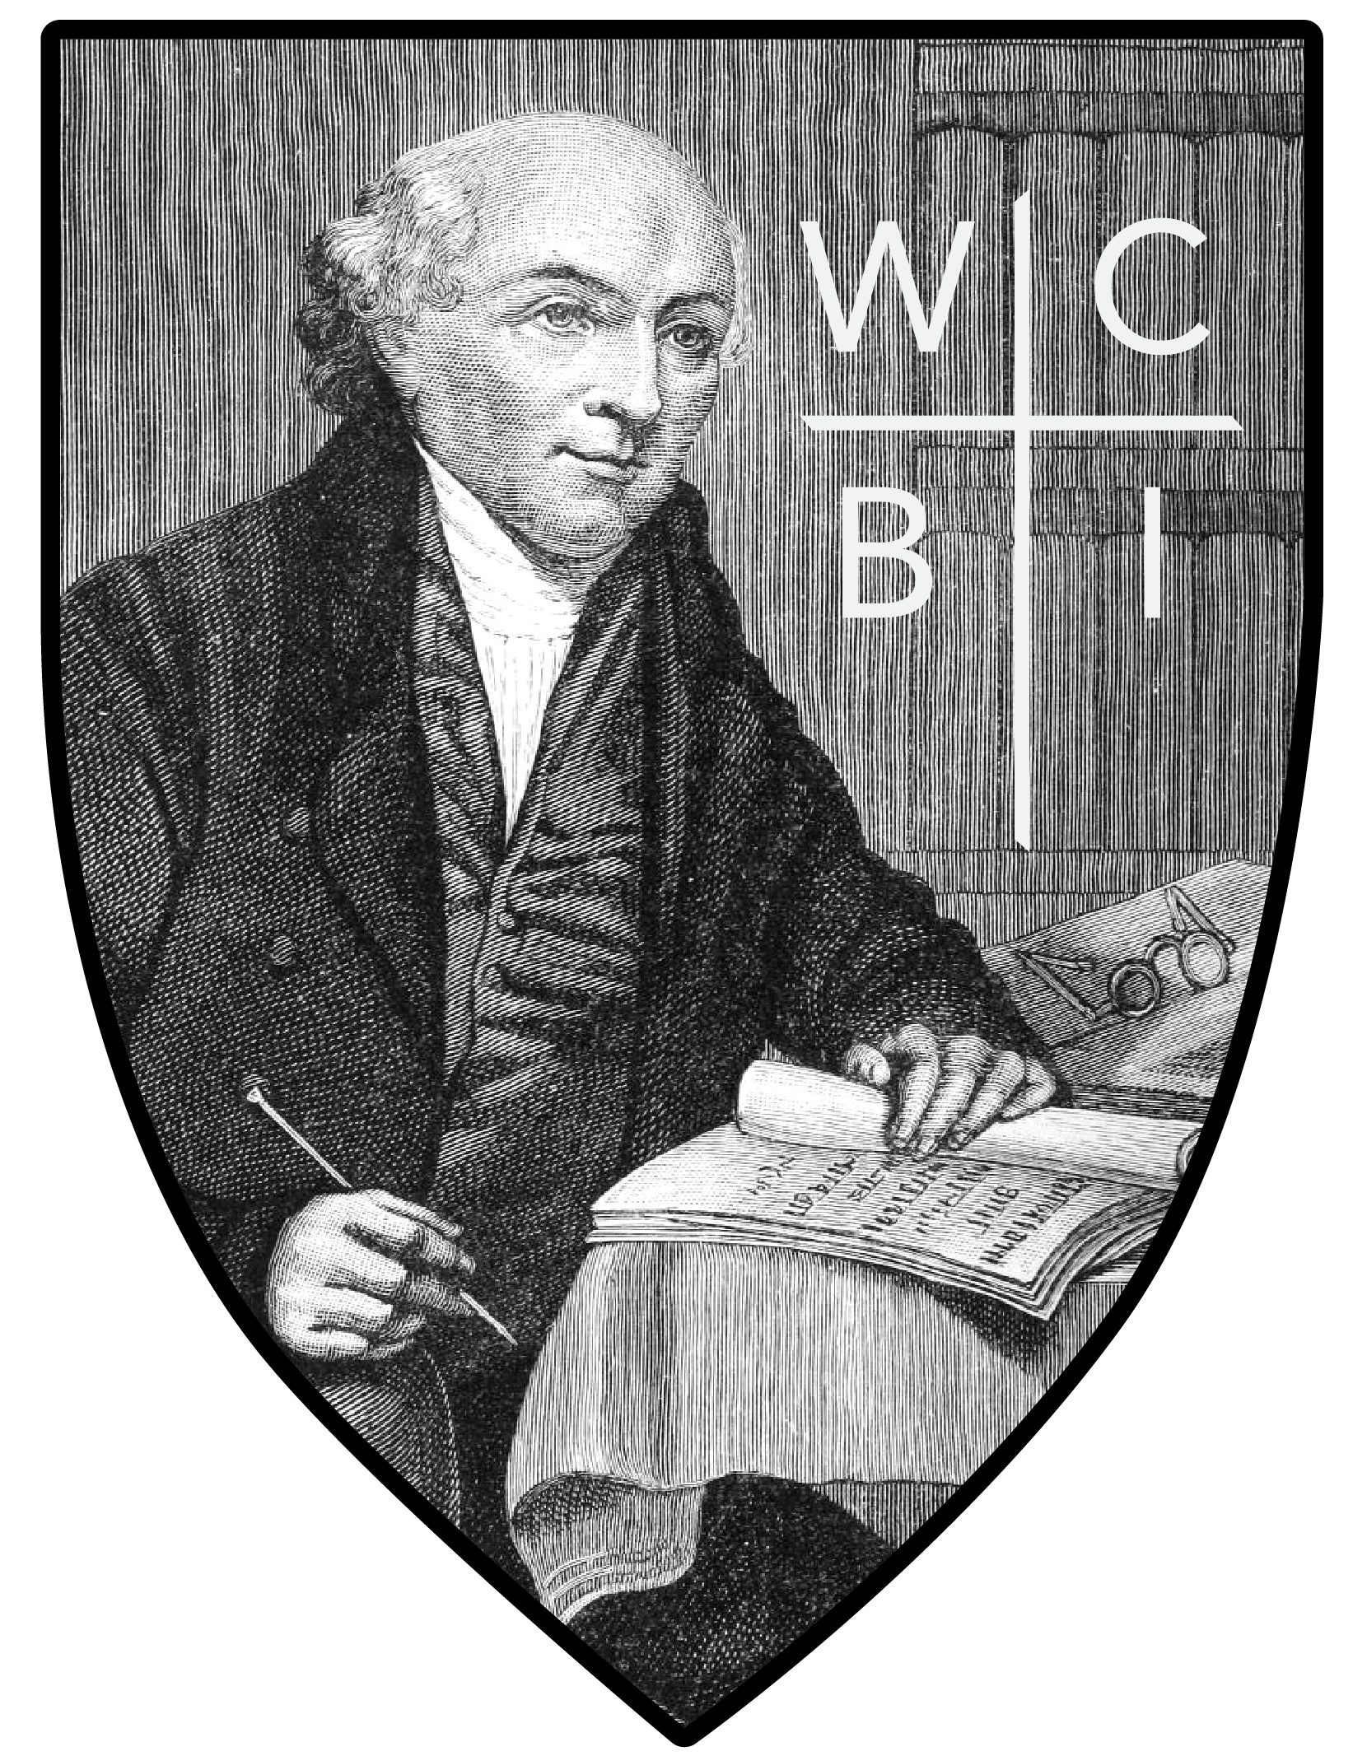

“Be diligent to present yourself approved to God, a worker who does not need to be ashamed, rightly dividing
the Word of Truth” 2 Timothy 2:15.

